Campus Parking

Software Requirements Specification

Version: 1.0.0

June 09, 2020

Team Members
Alekya Pochampally
Chetan Kudaravalli
Chinmayi Ambati
Manideep Chamala
Manisha Mengani
Xizi Chen

Submitted in partial fulfillment
Of the requirements of
CSIS 44-691 Graduate Directed Project 1

Revision History

Date | Description | Author | Comments
June 10, 2020 | Introduction to the project | Chetan Kudaravalli,  Manideep Chamala | Added Introduction chapter-1
June 10, 2020 | General description of the project | Alekya Pochampally,  Chinmayi Ambati | Added general description of project chapter-2
June 10,  2020 | Requirements of the project | Manisha Mengani,  Xizi Chen | Added requirements of the project chapter-3

Document Approval

The following Software Requirements Specification has been accepted and approved by the following:

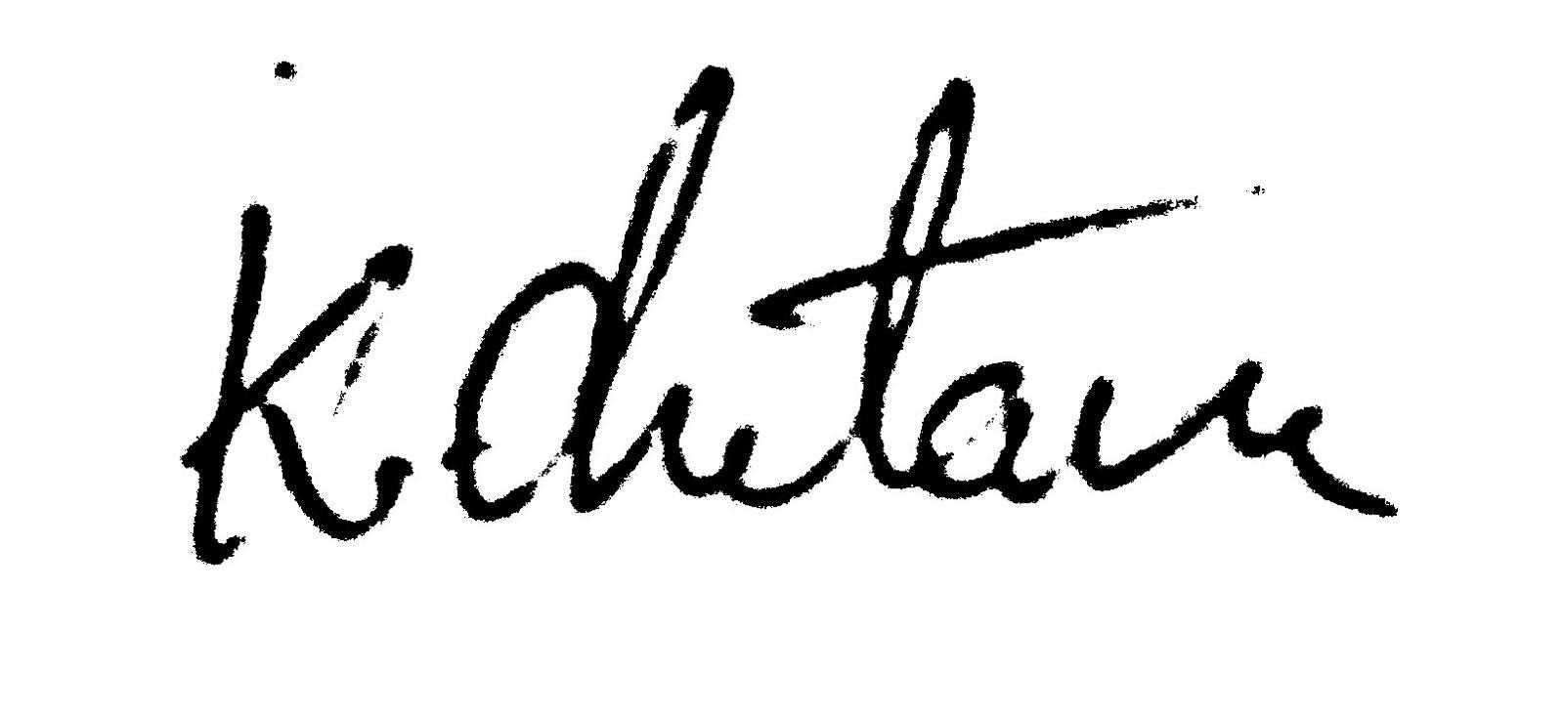 | Chetan Kudaravalli | Mr. | June 10, 2020
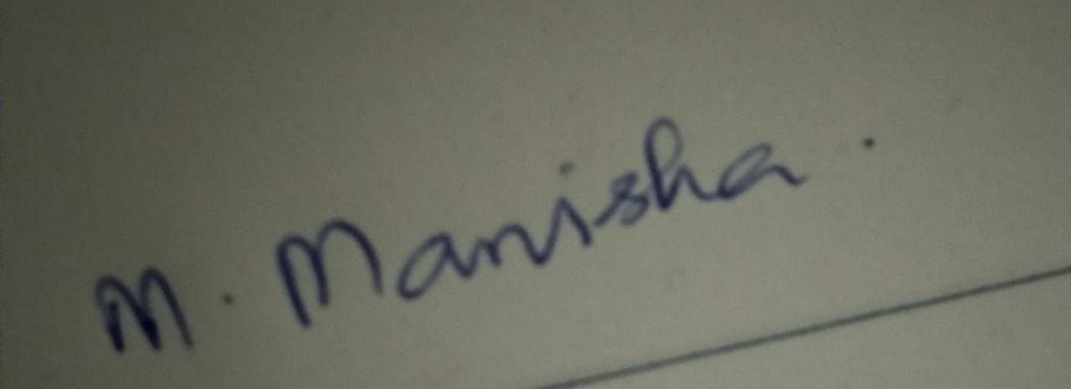 | Manisha Mengani | Ms. | June 10, 2020
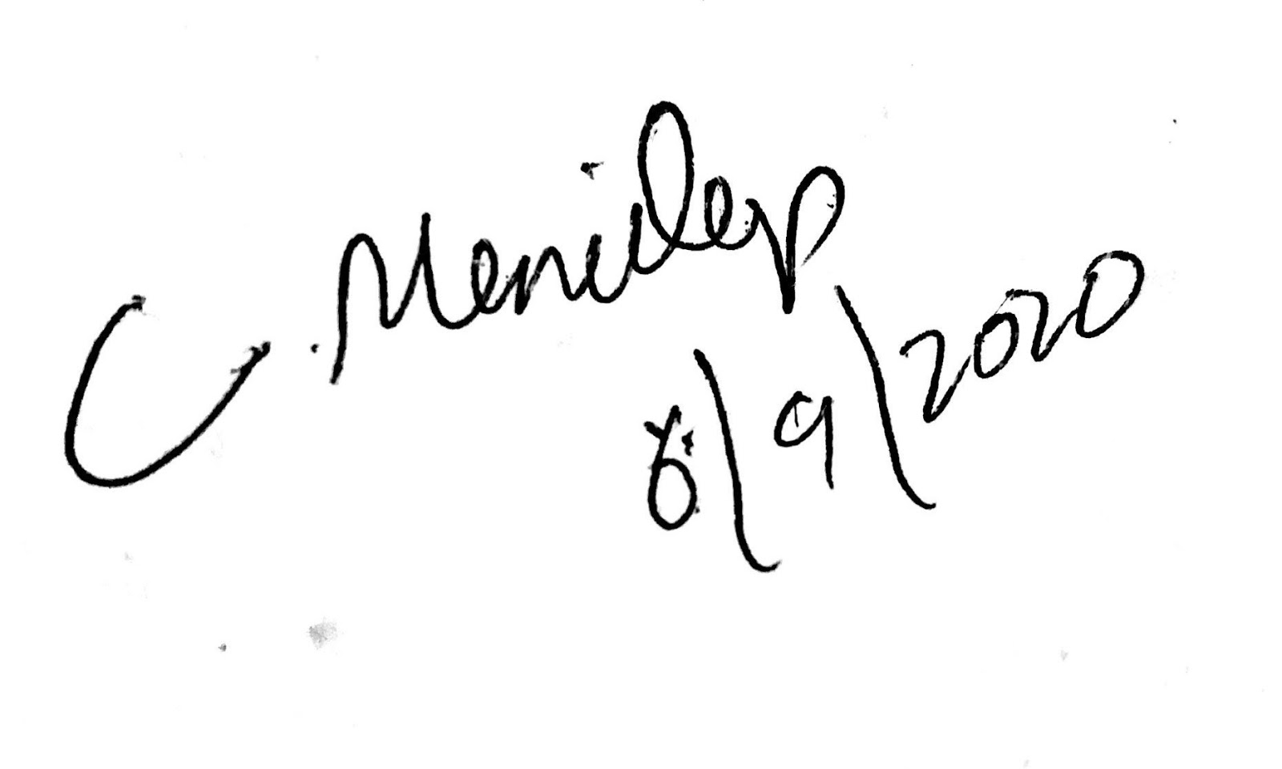 | Manideep Chamala | Mr. | June 10, 2020
 | Alekya Pochampally | Ms. | June 10, 2020
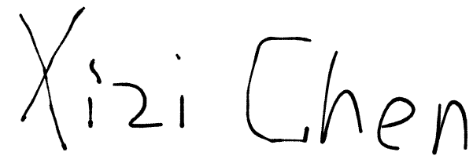 | Xizi Chen | Mr. | June 10, 2020
 | Chinmayi Ambati | Ms. | June 10, 2020

Table of Contents

Table of Contents Page Number

- Introduction
  - Purpose
  - Scope
  - Definitions, Acronyms, and Abbreviations
  - References
  - Overview
- General Description
  - Product Perspective
  - Product Functions
  - User Characteristics
  - General Constraints
  - Assumptions and Dependencies
- Specific Requirements
  - External Interface Requirements
    - User Interfaces
    - Hardware Interfaces
    - Software Interfaces
    - Communications Interface
  - Functional Requirements
  - Use Cases
  - Class/Objects
  - Non-Functional Requirements
3.5.1. Performance
3.5.2. Reliability
    - Availability
    - Security
    - Portability
  - Inverse Requirements
  - Design Constraints
  - Logical Database Requirements
  - Other Requirements
  - Prototypes (for complete project)
  - Use Case Diagrams
- Design
4.1. ER diagram
4.2. GUI
- Analysis Models
5.1. Data Flow Diagram
5.2. Sequence Diagram
6. Technical Manual
6.1. Feature Included in the Template
6.2. Installing the Software Manual Template
6.3. Front End Development
6.4. Back End Development
7. End-User Manual
7.1. Login Screen
7.2. Sign up
7.3. Forgot password

CHAPTER 1

Introduction
1.1 Purpose
It is basic that Students and faculty have to get to class on time and quite often we see a lot of delay in searching for free parking space. We are introducing the Campus Parking app which gives people the best option in saving time in searching for the free parking space on the campus. The app shows users how many open spaces are available in selected campus parking lots. Not only this, but the app also gives details about the positions of Faculty, Student, Handicapped, and also the Visitor parking in the Campus area.

1.2 Scope
Initially, we have a couple of options that the particular university has to execute for the best use of the app. First thing is that the university may issue a rule that every user must install the app to use the campus parking and as there are no censors coming into the play the user itself has to select the parking space in the app once it is occupied by that user, so that once the user selects the particular parking space that they occupied, that particular parking space turns into Red color and the remaining empty spaces will be as it is in White color making everyone know the availability of free parking spaces. This can be achieved by just using Notices round the Campus Parking Zone and on Campus.
The second thing which is an alternative to the first step and also which could be a better idea is that the University may allot separate parking lots for this app so that only users who have this app installed with them can use this space without having conflicts with the users who don't have this app installed.

1.3 Definitions, Acronyms, and Abbreviations

The following terms, acronyms, and abbreviations are used throughout this document.
Campus Parking App: We use this term many times and this is the actual app name that we are going to develop in the project which is Campus Parking. This helps users to know the availability of parking spaces in the Campus.
Faculty, Student, and Visitor: All these three terms refer to almost the same thing that these are the USERs who are going to use the parking space in the Campus and who has the app installed.
Reserved: This refers to the parking space that is already filled by other users.
Vacant: This refers to the parking space that is empty and any user can use the appropriate space by notifying the other users. This includes both the cases where the user forgets to update that he vacated the parking slot and also if the user reserved a slot and didn’t update it to the app.
Token: Token refers to the change that’s imposed on the user if he fails to update the usage of the parking lot.
Parking Lots: This refers to a cleared area that is intended for parking vehicles. Usually, the term refers to a dedicated area that has been provided with a durable or semi-durable surface.

1.4 References
• https://fluttercrashcourse.com/
• https://www.tutorialspoint.com/dart_programming/index.htm
• https://flutter.dev/

1.5 Overview
Campus Parking App provides users the details of the availability of the parking spaces in the Campus Parking Lot which also differentiates between Student, Faculty, and Visitors. This helps the users in saving big time in searching for the Parking space in the Campus.

Chapter 2
General Description
2.1 Product Perspective
The main perspective of campus parking application is to be helpful for students, faculty, or visitors to book a parking slot without any struggle during peak times.
2.2 Product Functions
The functions of this application are divided among a team of 6 members and assigned their roles to develop, with daily meetings and discussions for daily progress in the app.
2.3 User Characteristics
There are different types of users in this application such as students, faculty, and visitors. Firstly, everyone has to register in to the app to book a slot in the parking lot. After that, their characteristics depend on the type of parking they need such as handicapped, visitor, or faculty/worker parking. They are restricted to the availability of slots in a parking lot. This application serves as a first come first serve for users. Users can have their profile and report other vehicles with an image.
2.4 General Constraints
We as a team of 6 members have divided the application into various segments and decided to complete in 5 months and allocated a deadline for phase 1 which is the 1st week of July.
2.5 Assumptions and Dependencies
According to our project plan, we have to gather all our requirements which are necessary for the app development, then to have use cases and design ER-Diagram to represent the relationships between entities. At this stage, we have these assumptions for our project
• Setting up a developer environment according to required technologies.
• Setting up the project for both frontend and backend in Github.
• Designing the prototype of the project
• Listing out all the functionalities to be provided in the project and work distribution
• Designing UI – Login Page, functionality – A login page, Designing UI – Home page
and Designing UI – Login Page.
• Routing the page navigations and building the database where we populating data into
database.
• Merging the frontend and backend and debugging till then.

Chapter 3

Specific Requirements

- External Interface Requirements
3.1.1 User Interfaces
3.1.1.1 Login page
This page will show the title of the app, prompts, and text boxes that allow the user input username/password.
Button “Sign up” for creating a new account.
Button “Sign in” for login
Button “Reset” for resetting one’s password.
3.1.1.2 New User Page
This page will show text boxes, prompts where users can input their details and register in the application.
3.1.1.3 Reset password
This page will allow the user to reset his forgotten password with a new password through a valid username.
3.1.1.4 Home page
This page will have buttons such as maps, reports, logout, and parking lots, where there are various parking lots in the university.
3.1.1.5 Map Page
This page will have a top view image of all parking lots where users can zoom in and out, back, and navigation buttons.
3.1.1.6 Parking Area Page
This page will show available lots for parking which is interactive like select/unselect and two buttons such as home and reserve.
3.1.1.7 Select Slot Page
This page will allow users to select an available slot in the parking lot which has slot id as down drop text box and back, cancel, reserve as buttons.
3.1.1.8 Profile Page
This page will have text boxes such as vehicle number, tickets, and vehicle type and a button back to return home.
3.1.1.9 Report page
This page will have vehicle number and image as text boxes and back, cancel, report as buttons.

3.1.2 Hardware Interfaces
• Processor: Minimum 1 GHz; Recommended 2GHz or more
• Wireless adapter (Wi-Fi) OR Mobile Data (3G/LTE)
• Hard Drive: Minimum 16 GB; Recommended 64 GB or more
• Memory (RAM): Minimum 1 GB; Recommended 4 GB or above

3.1.3 Software Interfaces
• Flutter
• SQLite
• Dart
• Visual Studio

3.1.4 Communications Interface
• IOS
• Android

- Functional Requirements
A new user can sign up as a common user which could add one’s vehicle to the account. A common user could sign in, view, and manage his account including user information, vehicle, and balance.
Admin users not only have all functions of the common user but also can add funds for users.
3.2.1 Login
Users can login to the application.
3.2.2 Sign up
Users can register into the application.
3.2.3 Password reset
User can reset their application when they are unable to login with their current
credentials.
3.2.4 Logout
Users can exit the application by logging out.
3.2.5 Parking lots
Users can view the list of all parking lots in the university.
3.2.6 Occupy slot
Users can occupy a parking slot at the time of parking their vehicle in the slot.
3.2.7 Vacate slot
Users can vacate the parking slot at the time of removing their vehicle from the slot.
3.2.8 Map review
Users can see the university map to identify the location of parking lots in the campus.
3.2.9 Vacancy/Occupancy correction report
The user can report admin if there is any inconsistent data in the application.
3.2.10 User profile
Users can view their profile which contains the name, vehicle details, number of
tickets they have, etc.

3.2.11 Parking Tickets
If the user forgets to update the app (occupy/vacant) they will be fined.
3.2.12 Report violations
If a vehicle without a parking permit is parked, it can be reported.
3.2.13 FAQ and contact us
Users can view the frequently asked questions in the applications and as well as post
their queries. They can also contact us via email and there will also be a live chat
feature in the application.
3.2.14 Admin module
Admin will also be having a login. They will be having complete access to the
application i.e, they have access to both front end and also backend. In the backend
they can modify the changes to parking lots, number of slots in each parking lot,
number of available/ reserve slots, etc. They can even reserve parking lots for a
specific time for visitors.

- Use Cases

- Class/Objects

- Non-Functional Requirements
3.5.1 Performance
3.5.2 Reliability
3.5.3 Availability
3.5.4 Security
3.5.5 Portability

- Inverse Requirements

- Design Constraints

- Logical Database Requirements

- Other Requirements

- Prototypes (for the complete project)

- Use Case Diagrams

Chapter 4

Design

4.1 ER Diagram

Below is the ER Diagram of our application where we have 5 entities: token, user, slot, vehicle and parking lots.

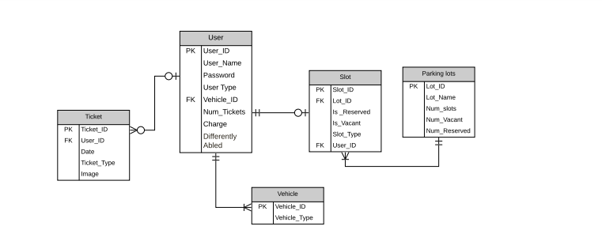

4.1.1 About ER Diagram
There are 5 entities namely Tickets, User, Slot, Parking lots, Vehicle.
4.1.1.1 Ticket
This entity is used for finding the user if they forget to update the application. The
users will be charged based on the number of tickets they have. This entity will be
having few attributes like
· Date : which will be telling the user on which day they got fined.
· Image : image of the screenshot or user vehicle
· Token type : reserve/ vacant
· UserID : This is the foreign key of the table and user to identify an individual
Relations : Each ticket is for 1 user only.

4.1.1.2 User
This entity is used to represent an individual using this app. The following are the attributes
· UserID : Unique number for each user
· User_Name : Name of the user
· Password : Password of the user
· User Type: faculty or student
· Vehicle_ID: this is a foreign key used to track individuals vehicle
· Num_Ticket: Number of tokens per user
· Charge: will be calculated based on the number of tickets users have.
· Differently abled: This is used for directing to reserved parking slots for specific users
Relations : Each user can have
· multiple tickets
· multiple vehicles
· 0 or 1 slot

4.1.1.3 Vehicle Entity
This entity represents the vehicle used by the user. The following are its attributes
· Vehicle_ID: This is a primary key used to uniquely identify the vehicle
· Vehicle_Type: 2 or 4 wheeler
Relations: 1 Vehicle will be having only 1 user

4.1.1.4 Parking lots
This entity represents all the parking lots in the university. The following are its attributes
· Lot_ID: This is the primary key and uniquely identify particular parking lot
· Lot_Name: name of the parking lot
· Num_slots: this gives the capacity of the parking lot
· Num_Vacant: Number of available slots for parking
· Num_Reserved: Number of reserved slots
Relations: Each parking lot can have 1 or more slots

4.1.1.5 Slot
This entity represents each slot in any parking lot. This entity have the following attributes
· Slot_ID: This is the primary key and uniquely identifies each slot
· Lot_ID: This is the foreign key and represents the Lot_ID in parking lots entity
· Is_Reserved: states whether the entity is reserved or not
· Is_Vacant: states whether the entity is vacant or not.
· Slot_Type: slot meant for differently abled persons or not.
· User_ID: this is a foreign key which identifies users uniquely.
Relations:
· Each slot have 1 user
· Belongs to only 1 parking lot

4.2 GUI

These are mockup’s of our application’s Graphical user interface.

Login Page Home Page

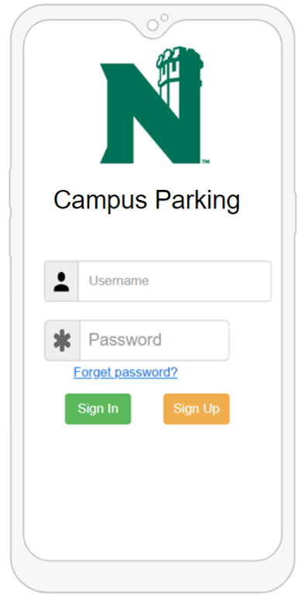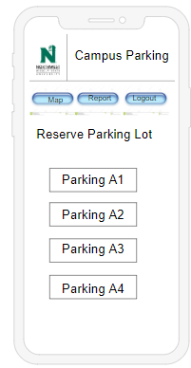

Index Page Parking Page

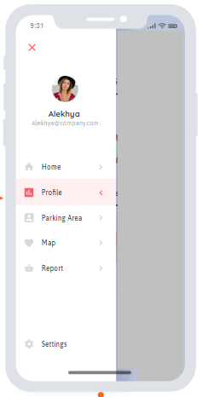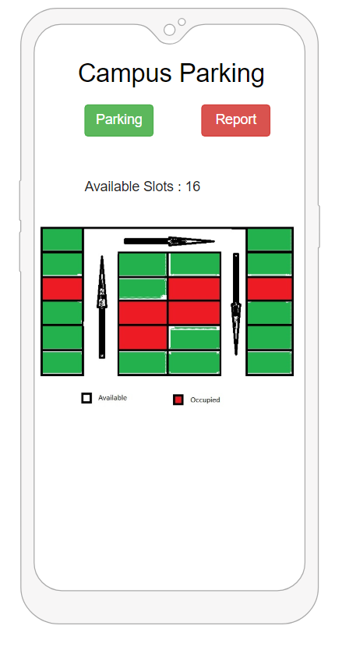

Map Page Report Page

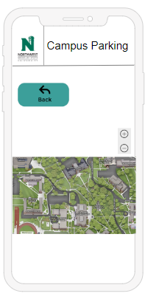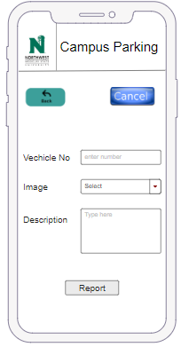

Forgot Password Page Profile Page

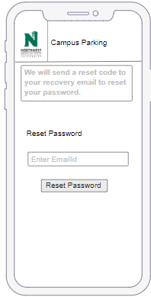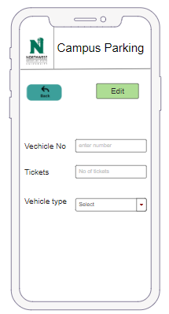

Connection Page

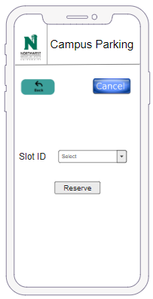

CHAPTER 6

Technical Manual

6.1. Features of the application
Listing of features application currently includes:
- Sign in
- Sign up
- Reset password
This application is intended to attain parking slots at Northwest Missouri University and operates on smartphones (Android 5.0 or newer/ IOS 7 or newer).

6.2. Installing the Software Manual

- For Android phones, run the .apk file.
- For the iPhone, install iphone SDK.

6.3. Front End development

6.3.1 Login page

For clear understanding a detailed comment is mentioned inside the code for the login page.

class LoginPage extends StatefulWidget {
static const String route = '/login';

@override
_LoginPageState createState() => _LoginPageState();
}

- Every class created must extend any of the state framework. A stateful widget can call create state() method multiple times over its lifetime. A widget has a mutable state, route for the page is created in the login page class.

class _LoginPageState extends State<LoginPage> {
final _formKey = GlobalKey<FormState>();
UserServices _userServices = UserServices();

String _email;
String _password;

@override
void initState() {
super.initState();
}

- global key uniquely identifies the form widget which makes the validation easy._email and _password are the form elements of the login form.
initState() is used to insert widgets inside the stateful tree.

@override
Widget build(BuildContext context) {
//building a form widget using _formkey provided earlier
return Scaffold(

// scaffold is a framework to provide a basic layout to the application.

appBar: ApplicationBar(),
//appBar is used to provide fixed height widget to the screen

body: SafeArea(
//Safe area considers its padding and adjustments of the screen which works for both android and iPhone

child: Form(
key: _formKey,
//_formkey widget is used to start its functionality
child: Padding(
padding: EdgeInsets.all(10),
child: ListView(
// child is the layout widget in dart
children: [
Container(
// container combines positioning and sizing widgets
alignment: Alignment.center,
padding: EdgeInsets.all(10),
child: Text(
'Campus Parking',
style: TextStyle(fontWeight: FontWeight.w600, fontSize: 30),
),
),
Container(
alignment: Alignment.center,
padding: EdgeInsets.all(10),
child: Text(
'Login',
style: TextStyle(fontSize: 20),
),
),
)
}

Below are the form elements which are inserted into individual containers for their alignment and positionings

// Username
Container(
padding: EdgeInsets.all(10),
child: TextFormField(
keyboardType: TextInputType.emailAddress,
decoration: InputDecoration(
border: OutlineInputBorder(),
// border online for the form
labelText: 'Email Id',
// email label of type text
),
validator: (value) {
if (value.isEmpty) {
return 'Provide an email id';
// validations check if value provided is empty
}
_formKey.currentState.save();
return null;
},
onSaved: (value) {
_email = value;
},
),
),

Check the password form element which with its alignment

// Password
Container(
padding: EdgeInsets.all(10),
child: TextFormField(
obscureText: true,
// is used to hide the input given
decoration: InputDecoration(
border: OutlineInputBorder(),
labelText: 'Password',
// label password for text type
),
validator: (value) {
if (value.isEmpty) {
return 'Provide your password';
}
_formKey.currentState.save();
return null;
},
onSaved: (value) {
// optional value to be saved with the final value after form is saved
_password = value;
},
),
),

The code below illustrates the actions that need to be performed after login button
is pressed.

// Login button
Container(
height: 55,
padding: EdgeInsets.fromLTRB(10, 0, 10, 0),
child: RaisedButton(
onPressed: () async {
if (_formKey.currentState.validate()) {
_formKey.currentState.save();
var authenticateUserRequest = AuthenticateUserRequest(emailId: _email, password: _password);
//after successful entering the username and password,authentication call is sent to backend
final result =
await _userServices.authenticate(authenticateUserRequest);
// waits until it receives back the data
if (result != null) {
var sharedPreference = await SharedPreferences.getInstance();
sharedPreference.setString('cp_token', result.token);
Navigator.of(context).pushReplacementNamed(UserHomePage.route);
}
}
},
child: Text(
'Login',
style: TextStyle(fontSize: 18),
),
),
),

button functionality for forgot password and signup is made available below the login button.
This is completely immersed in to a single container and aligned into single child element

// Signup information
Container(
child: Row(
mainAxisAlignment: MainAxisAlignment.center,
// alignment of the buttons to appear
children: [
// single child element for both the buttons
FlatButton(
onPressed: () => Navigator.of(context)
.pushNamed(ForgotPasswordPage.route),
// navigating to forgot page if user clicks on forgot password button
child: Text('Forgot Password')),
FlatButton(
onPressed: () =>
Navigator.of(context).pushNamed(SignUpPage.route),
// navigating to signup page which will be discussed below
child: Text('Sign Up'))
],

Type ID and password where indicated, then tap the Login button if ID and password correct page will navigate into the application

6.3.2 Sign up page

- When a user clicks on sign up this snippet helps to route to sign up page and the class extends statefulwidget as usual for implementing other widgets.

class SignUpPage extends StatefulWidget {
static const String route = '/sign-up';

@override
_SignUpPageState createState() => _SignUpPageState();
}

- This is a simple declaration for the containers we are going to use for user input where the class extends State<signupPage>.

class _SignUpPageState extends State<SignUpPage> {
final _formKey = GlobalKey<FormState>();

CreateUserBloc _createUserBloc;
UserServices _userServices = UserServices();

String _emailId;
String _name;
String _registrationPlate;
String _password;
String _repeatPassword;

- This is a small part of the widget where we have a container which is the title of the page “Create an account” and then there are many other containers for text boxes and buttons.
@override
void initState() {
super.initState();
}

@override
Widget build(BuildContext context) {
return Scaffold(
appBar: ApplicationBar(),
body: Form(
key: _formKey,
child: SafeArea(
child: Padding(
padding: EdgeInsets.all(10),
child: ListView(
children: [
Container(
alignment: Alignment.center,
padding: EdgeInsets.all(10),
child: Text(
'Create an account',
style: TextStyle(fontWeight: FontWeight.w600, fontSize: 30),
),
),

6.3.3. Forgot password page

- This code is a route to the forgot password page when the user clicks on forgot password and extends statefulWidget.

class ForgotPasswordPage extends StatefulWidget {
static const String route = '/forgot-password';

@override
_ForgotPasswordPageState createState() => _ForgotPasswordPageState();
}

- The class forgot password has only two variables, email and otp as strings. As the page contains two text fields and two buttons.

class _ForgotPasswordPageState extends State<ForgotPasswordPage> {
final _formKey = GlobalKey<FormState>();

UserServices _userServices = UserServices();

String _email;
String _otp;

- The two text fields are email which is taken from the user for conformation and code which is like OTP to conform it is the same user. The two buttons are “send code” and “verify code”.

- Here you can see the widget for forgot password and container where it contains forgot password as title and in actual code, you can see building up other containers for other fields as shown in UI page.

@override
void initState() {
super.initState();
}

@override
Widget build(BuildContext context) {
return Scaffold(
appBar: ApplicationBar(),
body: SafeArea(
child: Form(
child: Padding(
padding: EdgeInsets.all(10),
child: ListView(
children: [
Container(
alignment: Alignment.center,
padding: EdgeInsets.all(10),
child: Text(
'Forgot Password',
style: TextStyle(fontWeight: FontWeight.w600, fontSize: 30),
),
),

6.3.4 Change password page

Routing code for changing password page, routes to this page when the user presses on “verify code” and if the code is matched with the sent code.

class ChangePasswordPage extends StatefulWidget {
static const String route = '/change-password';

@override
_ChangePasswordPageState createState() => _ChangePasswordPageState();
}

This class contains widgets and containers, where it contains two text boxes and one button.

Two text boxes are “New password” and “re-enter new password”, if both are same and password matches with required constraints the password will be updated.

class _ChangePasswordPageState extends State<ChangePasswordPage> {
@override
Widget build(BuildContext context) {
return Scaffold(
appBar: ApplicationBar(),
body: SafeArea(
child: Padding(
padding: EdgeInsets.all(10),
child: ListView(
children: [
Container(
alignment: Alignment.center,
padding: EdgeInsets.all(10),
child: Text(
'Reset Password',
style: TextStyle(fontWeight: FontWeight.w600, fontSize: 30),
),
),
Container(
alignment: Alignment.center,
padding: EdgeInsets.all(10),
child: Text('Please provide a new password and verify it'),
),
SizedBox(height: 25),
Container(
padding: EdgeInsets.all(10),
child: TextField(
obscureText: true,
decoration: InputDecoration(
border: OutlineInputBorder(),
labelText: 'New Password',
),
),
),
Container(
padding: EdgeInsets.all(10),
child: TextField(
obscureText: true,
decoration: InputDecoration(
border: OutlineInputBorder(),
labelText: 'Verify Password',
),
),
),
Container(
height: 55,
padding: EdgeInsets.fromLTRB(10, 0, 10, 0),
child: RaisedButton(
onPressed: () => {},
child: Text(
'Change Password',
style: TextStyle(fontSize: 18),
),
),
),
],
),
),
),
);
}
}

6.3.5 User Home page

Routes to this page, when the user opens his application and also routes to the same page whenever user logouts.

class UserHomePage extends StatefulWidget {
static const String route = '/user-home';

@override
_UserHomePageState createState() => _UserHomePageState();
}

The user home page consists of the user home sample as title as of now and also consists of a logout button.

class _UserHomePageState extends State<UserHomePage> {
@override
Widget build(BuildContext context) {
return Container(
child: Column(
children: [
Text('User Home sample'),
RaisedButton(
onPressed: () async {
var sharedPreference = await SharedPreferences.getInstance();
sharedPreference.remove('cp_token');
Navigator.of(context).pushReplacementNamed(LoginPage.route);
},
child: Text('Logout'),
)
],
),
);
}
}

6.3.6 splash screen
This is a splash screen page which extends stateful widget and has base authentication.

class SplashScreenPage extends StatefulWidget {
final BaseAuthentication authentication;

SplashScreenPage({this.authentication});

@override
_SplashScreenPageState createState() => _SplashScreenPageState();
}
This class uses splash screen page userid as a variable to check whether the user is valid or not and authenticate him to allow access to the application.

class _SplashScreenPageState extends State<SplashScreenPage> {
AuthenticationStatus authenticationStatus =
AuthenticationStatus.NOT_AUTHENTICATED;
String _userId = "";

@override
void initState() {
super.initState();

widget.authentication.getCurrentUser().then((user) {
setState(() {
if (user != null) {
_userId = user?.uid;
}
authenticationStatus = user?.uid == null
? AuthenticationStatus.NOT_AUTHENTICATED
: AuthenticationStatus.AUTHENTICATED;
});
});
}

@override
Widget build(BuildContext context) {
switch (authenticationStatus) {
case AuthenticationStatus.INDETERMINATE:
return buildWaitingScreen();
break;
case AuthenticationStatus.NOT_AUTHENTICATED:
return new LoginPage(
baseAuthentication: widget.authentication,
loginCallback: loginCallback,
);
break;
case AuthenticationStatus.AUTHENTICATED:
if (_userId.length > 0 && _userId != null) {
return new UserHomePage(
userId: _userId,
basicAuthentication: widget.authentication,
logoutCallback: logoutCallback,
);
} else
return buildWaitingScreen();
break;
default:
return buildWaitingScreen();
}
}

6.3.7 Reset Password page
This page implemented in change_password_page.dart as follow:
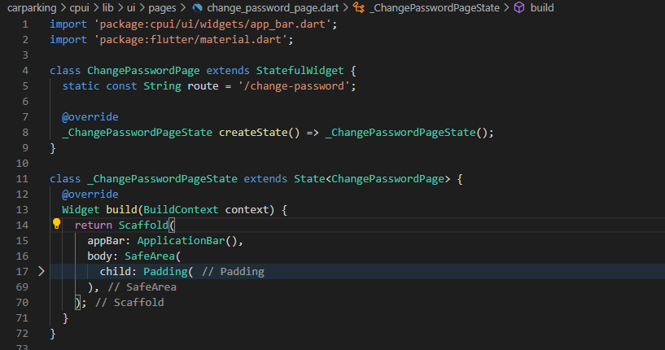

The folded line 17 which consists of 5 containers and layout as listview.
The first 2 containers are texts.
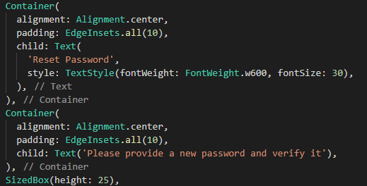

The following 2 are text fields.
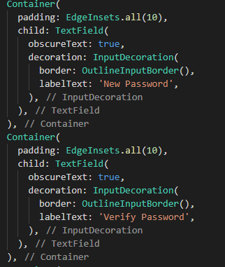

The last container is a button.
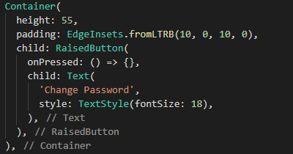

Below is the capture of this page.
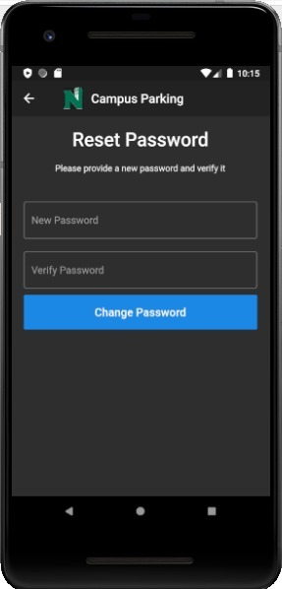

6.4. Back End development

6.4.1 Configurations

6.4.1.1 Application configuration

This code contains comments which clearly explains the functionality, where it contains several variables which are used by the application and it was named as application configuration.

/**
* Application level common thread pool for all @{@link org.springframework.scheduling.annotation.Async} task
* executions.
*
* @param poolSize Pool size
* @param maxPoolSize Max pool size
* @param queueCapacity Max queue capacity
* @param threadNamePrefix Prefix for thread names associated with this pool
* @return Executor for executing tasks in allocated thread pool
*/
@Bean(name = "asyncExecutionThreadPool")
public Executor asyncExecutionThreadPool(
@Value("${cp.thread-pool.pool-size:3}") int poolSize,
@Value("${cp.thread-pool.max-pool-size:5}") int maxPoolSize,
@Value("${cp.thread-pool.queue-capacity:100}") int queueCapacity,
@Value("${cp.thread-pool.thread-name-prefix}") String threadNamePrefix) {

ThreadPoolTaskExecutor threadPoolTaskExecutor = new ThreadPoolTaskExecutor();
threadPoolTaskExecutor.setCorePoolSize(poolSize);
threadPoolTaskExecutor.setMaxPoolSize(maxPoolSize);
threadPoolTaskExecutor.setQueueCapacity(queueCapacity);
threadPoolTaskExecutor.setThreadNamePrefix(threadNamePrefix);
threadPoolTaskExecutor.initialize();
return threadPoolTaskExecutor;
}

}

6.4.1.2 Application security configuration

This code is about parameters for security configurations for users authentication and reset password configurations.

@Configuration
@EnableWebSecurity
@RequiredArgsConstructor
public class ApplicationSecurityConfigurations extends WebSecurityConfigurerAdapter {

private final IJwtTokenProvider tokenProvider;

@Override
protected void configure(HttpSecurity http) throws Exception {
http.csrf().disable();

http.sessionManagement().sessionCreationPolicy(SessionCreationPolicy.STATELESS);

http.authorizeRequests()
.antMatchers("/api/users/create").permitAll()
.antMatchers("/api/users/authenticate").permitAll()
.antMatchers("/api/users/reset-password/**").permitAll()
.anyRequest().authenticated();

http.apply(new JwtTokenFilterConfigurer(tokenProvider));
}

@Bean
@Override
public AuthenticationManager authenticationManagerBean() throws Exception {
return super.authenticationManagerBean();
}

@Bean
public PasswordEncoder passwordEncoder() {
return new BCryptPasswordEncoder();
}

}

6.4.1.3 Application table naming strategy

This is for database identification through the user's name.

public class ApplicationTableNamingStrategy extends SpringPhysicalNamingStrategy {

@Override
public Identifier toPhysicalTableName(Identifier name, JdbcEnvironment jdbcEnvironment) {
String tableName = super.toPhysicalTableName(name, jdbcEnvironment).getText();
tableName = tableName.toUpperCase();
return Identifier.toIdentifier(String.format("CP_%s", tableName));
}

}

6.4.1.4 Application web configuration

This is web configuration which has MVC structure.

@Configuration
public class ApplicationWebConfigurations implements WebMvcConfigurer {

@Override
public void addResourceHandlers(ResourceHandlerRegistry registry) {
if (!registry.hasMappingForPattern("/ui/**")) {
registry.addResourceHandler("/ui/**")
.addResourceLocations("classpath:static/ui/");
}
}

@Override
public void addCorsMappings(CorsRegistry corsRegistry) {
corsRegistry.addMapping("/**")
.allowedOrigins("*");
}
}

6.4.2 Users

6.4.2.1 profile

This snippets is about user profile which has email id and registration page
@Getter
@Setter
@Builder
@ToString
@NoArgsConstructor
@AllArgsConstructor

@Entity
public class Profile {

@Id
private String emailId;

private String registrationPlate;
@Column(name="fullname")
private String name;

}

6.4.2.2 Role

public enum Role {

USER
}

6.4.2.3 User

This code snippet gives information about the user, whether his account is active or not.

public class User extends FunctionEntity<User> {

@Id
private String emailId;

@Column(nullable = false)
private String password;

private boolean isAccountActivated;

@OneToOne(
fetch = FetchType.LAZY,
cascade = CascadeType.ALL,
orphanRemoval = true
)
@JoinColumn(name = "password_reset_token_id")
private Token passwordResetToken;

@ElementCollection(targetClass = Role.class)
@Enumerated(EnumType.STRING)
@CollectionTable(name = "user_role")
@Column(name = "role", nullable = false)
private Set<Role> roles;

@MapsId
@OneToOne(
fetch = FetchType.LAZY,
cascade = CascadeType.ALL,
orphanRemoval = true
)
@JoinColumn(name = "emailId")
private Profile profile;

}

6.4.3 Requests

6.4.3.1 Authentication request

This code is used for request authentication from users.

@Getter
@Setter
@Builder
@NoArgsConstructor
@AllArgsConstructor
public class AuthenticationRequest implements IVerifiableRequestBody {

private String emailId;

private String password;

@Override
public Verified verify() {
return null;
}

}

6.4.3.2 create user request

This request for a sign up page with constraints for each text box.

public class CreateUserRequest implements IVerifiableRequestBody {

private String emailId;

private String password;

private String verifiedPassword;

private String registrationPlate;

private String name;

@Override

public Verified verify() {
if (emailId == null || emailId.trim().isEmpty()) {
return Verified.failedValidation("Email id cannot be empty");
}
if (password == null || password.trim().isEmpty()) {
return Verified.failedValidation("Password cannot be empty");
}
if (verifiedPassword == null || verifiedPassword.trim().isEmpty()) {
return Verified.failedValidation("Verification password cannot be empty");
}
if (password.length() <= 5) {
return Verified.failedValidation("Password must have 6 or more characters");
}
if (!password.equals(verifiedPassword)) {
return Verified.failedValidation("Password and verification passwords do not match");
}
if (registrationPlate == null || registrationPlate.trim().isEmpty()) {
return Verified.failedValidation("Registration plate cannot be empty");
}
if (name == null || name.trim().isEmpty()) {
return Verified.failedValidation("Name cannot be empty");
}
return Verified.passedValidation();
}

}

6.4.3.3 Reset password otp generation request

@Getter
@Setter
@Builder
@NoArgsConstructor
@AllArgsConstructor
public class ResetPasswordOtpGenerationRequest {

private String emailId;

}

6.4.3.3 Update password request

This request is when the user is trying to update his password and his constraints.

public class UpdatePasswordRequest implements IVerifiableRequestBody {

private String emailId;

private String newPassword;

private String verifyNewPassword;

@Override
public Verified verify() {
if (newPassword == null || newPassword.trim().isEmpty()) {
return Verified.failedValidation("Password cannot be empty");
}
if (verifyNewPassword == null || verifyNewPassword.trim().isEmpty()) {
return Verified.failedValidation("Verification password cannot be empty");
}
if (newPassword.length() <= 5) {
return Verified.failedValidation("Password must have 6 or more characters");
}
if (!newPassword.equals(verifyNewPassword)) {
return Verified.failedValidation("Password and verification passwords do not match");
}
return Verified.passedValidation();
}
}

6.4.3.3 verify password reset otp request

public class VerifyPasswordResetOtp {

private String emailId;

private String otp;
}

6.4.4 Responses

This is a code snippet for responses for every request on every page.

@RestController
@RequestMapping("/api/users")
@RequiredArgsConstructor
public class UserEndpoints {

public static final String PASSWORD_RESET = "Password Reset";
public static final String PASSWORD_RESET_MESSAGE = "Use following code: %s to reset your password";

private final IUserService userService;

private final PasswordEncoder passwordEncoder;

private final AuthenticationManager authenticationManager;

private final IJwtTokenProvider tokenProvider;

private final ITokenService tokenService;

private final IEmailService emailService;

@VerifyRequestBody
@PostMapping("/create")
public CreateUserResponse createUser(@RequestBody final CreateUserRequest userCreationRequest) {
return User.builder()
.emailId(userCreationRequest.getEmailId())
.password(passwordEncoder.encode(userCreationRequest.getPassword()))
.emailId(userCreationRequest.getEmailId())
.roles(List.of(Role.USER).toJavaSet())
.isAccountActivated(Boolean.TRUE)
.profile(
Profile.builder()
.emailId(userCreationRequest.getEmailId())
.name(userCreationRequest.getName())
.registrationPlate(userCreationRequest.getRegistrationPlate())
.build()
)
.build()
.andThenWith(userService::createNewUser)
.andThenTransform(
user -> CreateUserResponse.builder()
.emailId(user.getEmailId())
.name(user.getProfile().getName())
.registrationPlate(user.getProfile().getRegistrationPlate())
.build()
);

}

6.4.5 pom.xml

Add mysql dependency to <dependencies>
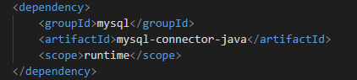

6.4.6 application.yml
Here .yml is the same as .properties. We use jpa mapping to the database table and set up necessary parameters.
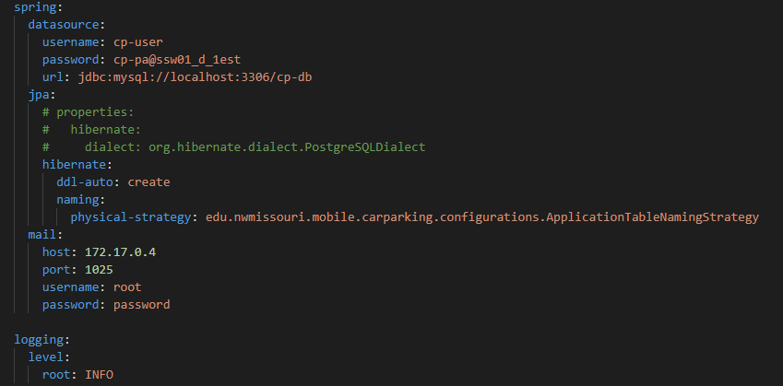

Chapter 7

End-user Manual

7.1 Login
Below is the landing screen once the user opens our application.
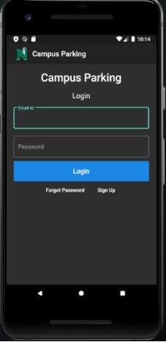
- If you're a new user please click on the signup button to stay signed in into the application. Actions to complete after clicking on the signup button are provided in 7.2 please refer to it.
- Once you're finished with the signup portion in the application you're qualified to go and sign in to the application.
- In the login page, you are prompted to enter the email address and password. Kindly use the email address and password that were provided on the sign-up page for the successful login.
- In any case, if the password doesn't match with the current and the earlier password given during signup please click on the forgot password button. It gets redirected to the reset password page. Please refer to 7.3 for detailed steps.

7.2 Sign up
Here is the sign-up screen of our application.
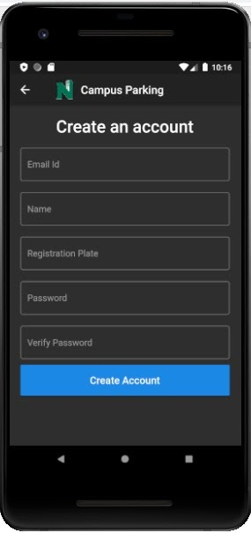
- In the signup page of the application, a new user must enter the email address which must be unique to the application. Please note if you have already signed up into the application then you're in the wrong window. Kindly refer to 7.1 and login to the application.
- If you forget your password, Kindly refer to 7.3 for more details.
- Signup page prompts for details like email address, name, registration plate, password, and password text fields which are mandatory to complete signup form in the application.

7.3 Forgot password
Here is the forgot password screen in the application.
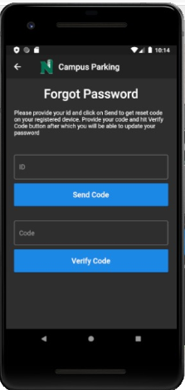
- User should type in one’s ID then tap button Send Code, an email with verification code will be sent.
- Type the code to Code text field, then tap the Verify Code button. If the code verification passed, the page will be navigated to the following page to reset the password.
- In this page, the user is required to input the new password in each text field. then tap the Change Password button. If the string in each text field is same, the new password will be applied.

